**Paper Title for FTT 2025**

First A. AuthorA, Second B. AuthorB, and Third C. AuthorB

ADepartment 1, Institution 1, State 1, Country 1

BDepartment 2, Institution 2, State 2, Country 2

E-mail: Corresponding author’s e-mail address

*Abstract*—**These instructions give you basic guidelines for preparing papers for the Extended Abstract of FTT 2025. Two-page Extended Abstract must be submitted using this format. This document is a template for Microsoft *Word*. If you are reading a printed-paper version of this document, please download the electronic file from the Symposium website, https://www.ftt2025.com, so you can use it to prepare your manuscript. To allow keyword indexing by retrieval software, please include appropriate keywords in your abstract, in alphabetical order, separated by commas.**

*Keywords*—**Fonts, formatting, margins**

I. INTRODUCTION

Your goal is to simulate, as closely as possible, the usual appearance of typeset papers in the *IEEE Transactions*. One difference is that the authors’ affiliations should appear immediately following their names – do not include your title there. For items not addressed in these instructions, please refer to a recent issue of any *Transactions*.

### II. METHODOLOGY

All extended abstract must be submitted electronically in pdf format. Prepare your abstract using a A4 page size of 210 mm × 297 mm (8.27" × 11.69").

1) *Type sizes and typeface*s: The best results will be obtained if your computer word processor has several type sizes. Try to follow the type sizes specified in Table I as best as you can. Use 14 point bold, capital letters for the title, 12 point Roman (normal) characters for author names and 10 point Roman characters for the main text and author's affiliations.

2) *Format*: In formatting your page, set top margin to 25 mm (1") and bottom margin to 31 mm (1 1/4”). Left and right margins should be 19 mm (3/4"). Use a two-column format. Indent paragraphs by 6 mm (1/4").

Left and right-justify your columns. Use tables and figures to adjust column length. All figures, tables, and equations must be included *in-line* with the text. Do not use links to external files.

III. RESULTS

## A. Figures and Tables

The resolution of figures should be better than 600 dpi for line art (graphics, charts, drawings or tables) and 220 dpi for photos and ~~gray scale~~ images. Colored figures are acceptable.

Position figures and tables at the tops and bottoms of columns. Avoid placing them in the middle of columns. Large figures and tables may span across both columns. Figure captions should be below the figures; table names and table captions should be above the tables. Use the abbreviation “Fig.” even at the beginning of a sentence.

Figure axis labels are often a source of confusion. Try to use words rather than symbols. As an example, write the quantity “Magnetization,” or “Magnetization *M*,” not just “*M*.” Put units in parentheses. Do not label axes only with units. As in Fig. 1, for example, write “Magnetization (A/m)” or “Magnetization (Am−1),” not just “A/m.” Do not label axes with a ratio of quantities and units. For example, write “Temperature (K),” not “Temperature/K.”

Multipliers can be especially confusing. Write “Magnetization (kA/m)” or “Magnetization (103 A/m).” Do not write “Magnetization (A/m) × 1000” because the reader would not know whether the top axis label in Fig. 1 meant 16000 A/m or 0.016 A/m. Figure labels should be legible, approximately 10-point type.

TABLE I

TYPE SIZES FOR CAMERA-READY PAPERS

|  |  |  |  |  |  |
| --- | --- | --- | --- | --- | --- |
| Type Size (pts) | Appearance | | | | |
| Regular | Bold | | Italic | |
| 7 | Table captions a |  | |  | |
| 8 | Section titles, tables, table names a, first letters in table captions a, table superscripts, figure captions, text subscripts and superscripts,  references, footnotes |  | |  | |
| 9 |  | Abstract | |  | |
| 10 | Authors’ affiliations, main text, equations, first letter in section titles a, first letter in table names a |  | | Subheading | |
| 12 | Authors’ names |  | |  | |
| 14 |  | Paper title | |  | |
|  | a Capital letters | |  | |  |

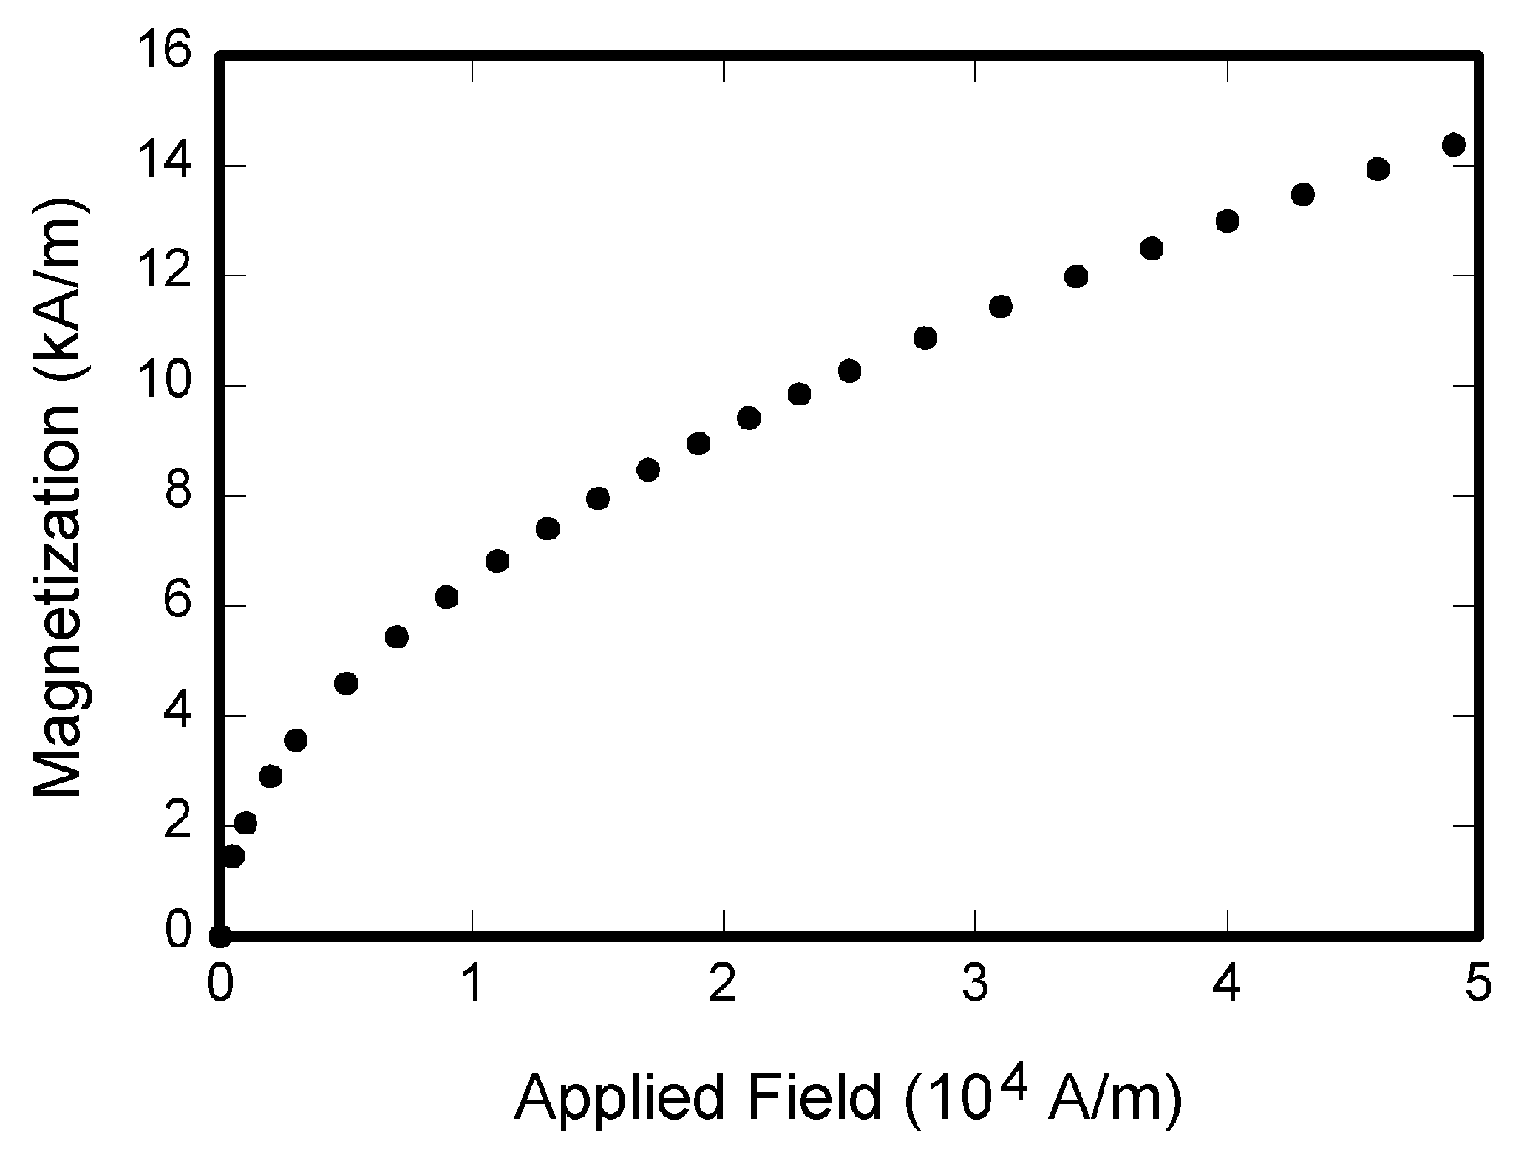

Fig. 1. Magnetization as a function of applied field.

Note how the caption is centered in the column.

*B. References*

Number citations consecutively in square brackets [1]. The sentence punctuation follows the bracket [2]. Refer simply to the reference number, as in [3]. Do not use “Ref. [3]” or “reference [3]” except at the beginning of a sentence:

“Reference [3] shows ... .”

Number footnotes separately in superscripts. Place the actual footnote at the bottom of the column in which it was cited. Do not put footnotes in the reference list. Use letters for table footnotes (see Table I).

Please note that the references at the end of this document are in the preferred referencing style. Give all authors’ names; do not use “*et al*.” unless there are six authors or more. Use a space after authors' initials. Papers that have not been published, even if they have been submitted for publication, should be cited as “unpublished” [4]. Papers that have been accepted for publication should be cited as “in press” [5].

Capitalize only the first word in a paper title, except for proper nouns and element symbols.

## C. Abbreviations and Acronyms

Define abbreviations and acronyms the first time they are used in the text, even after they have already been defined in the abstract. Abbreviations such as IEEE, SI, MKS, CGS, ac, dc, and rms do not have to be defined. Abbreviations that incorporate periods should not have spaces: write “C.N.R.S.,” not “C. N. R. S.” Do not use abbreviations in the title unless they are unavoidable (for example, “IEEE” in the title of this article).

### D. Equations

Number equations consecutively with equation numbers in parentheses flush with the right margin, as in (1). Use a long dash rather than a hyphen for a minus sign. Use parentheses to avoid ambiguities in denominators. Punctuate equations with commas or periods when they are part of a sentence, as in

*A* + *B* = *C*. (1)

Italicize variables (*T* might refer to temperature, but T is the unit tesla). Refer to “(1),” not “Eq. (1)” or “equation (1),” except at the beginning of a sentence: “Equation (1) is ... .”

IV. DISCUSSION

Use either SI (MKS) or CGS as primary units. (SI units are strongly encouraged.) Avoid combining SI and CGS units, such as current in amperes and magnetic field in oersteds. This often leads to confusion because equations do not balance dimensionally. If you must use mixed units, clearly state the units for each quantity that you use in an equation.

V. CONCLUSION

Finally, you are responsible for language as editors will not check it. If English is not your native language, get a professional proof-reader to help if possible.

ACKNOWLEDGMENT

Use the singular heading even if you have many acknowledgments. Avoid expressions such as “One of us (J.Q.A.) would like to thank ... .” Instead, write “J. Q. Author thanks ... .” Sponsor and financial support acknowledgments are placed in the unnumbered footnote on the first page.

REFERENCES

[1] D. J. Beebe, “Signal conversion (Book style with paper title and editor),” in *Biomedical Digital Signal Processing*, W. J. Tompkins, Ed. Englewood Cliffs, NJ: Prentice-Hall, 1993, ch. 3, pp. 61–74.

[2] M. Akay, *Time Frequency and Wavelets in Biomedical Signal Processing* (Book style). Piscataway, NJ: IEEE Press, 1998, pp. 123–135.

[3] G. B. Gentili, V. Tesi, M. Linari, and M. Marsili, “A versatile microwave plethysmograph for the monitoring of physiological parameters (Periodical style),” *IEEE Trans. Biomed. Eng.*, vol. 49, no. 10, pp. 1204–1210, Oct. 2002.

[4] V. Medina, R. Valdes, J. Azpiroz, and E. Sacristan, “Title of paper if known,” unpublished.

[5] E. H. Miller, “A note on reflector arrays (Periodical style—Accepted for publication),” *IEEE Trans. Antennas Propagat.*, in press.